August was AWESOME in the AMS Library!

Highlights:
- Video orientation, produced by students and featuring Bob, was shown to each grade in the café the 3rd day of school
- Each student received a library barcode number
- All students visited the library through ELA classes over 4 days to check out books
- 258 new items were added to the library (Junior Library Guild subscription, Barnes & Noble order, Book Fair, donations)
- Successful Book Fair: $11,535 in sales, resulting in $2,225 for the library; $900 in books for the library purchased from the Fair with Scholastic dollars.
- Computer carts were used 45 times
- Library used for 2 parent meetings
- Library Crew worked 83 times
- Adult volunteers worked 47 times
- Our users checked out 3,269 items (represents 22% of our collection)
- Students returned Summer Reading forms that showed 85 read 5 books or more
- The Librarian taught 5 8th grade RICA classes and assisted 7th grade students with choosing pictures and printing projects for a Social Studies project.

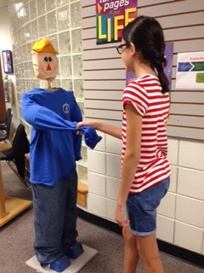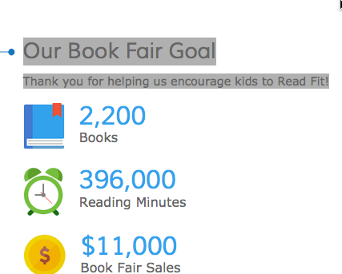
Student greets Bob during library
orientation. We exceeded our goal for the Book Fair!

