November Was Noteworthy in the AMS Library!

Biggest notes: Author Nathan Hale visited on Nov. 16. He ate lunch with 4 students who wrote letters to Mrs. Haggard. Then he captivated our 7th and 8th graders with his entertaining and informative presentation about the Lewis and Clark expedition. See pictures below.

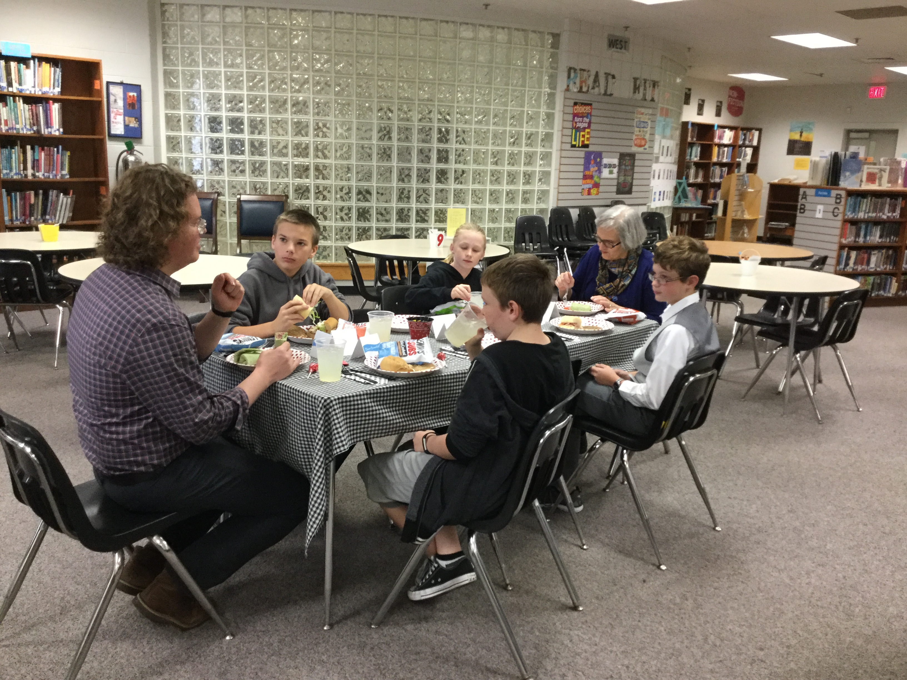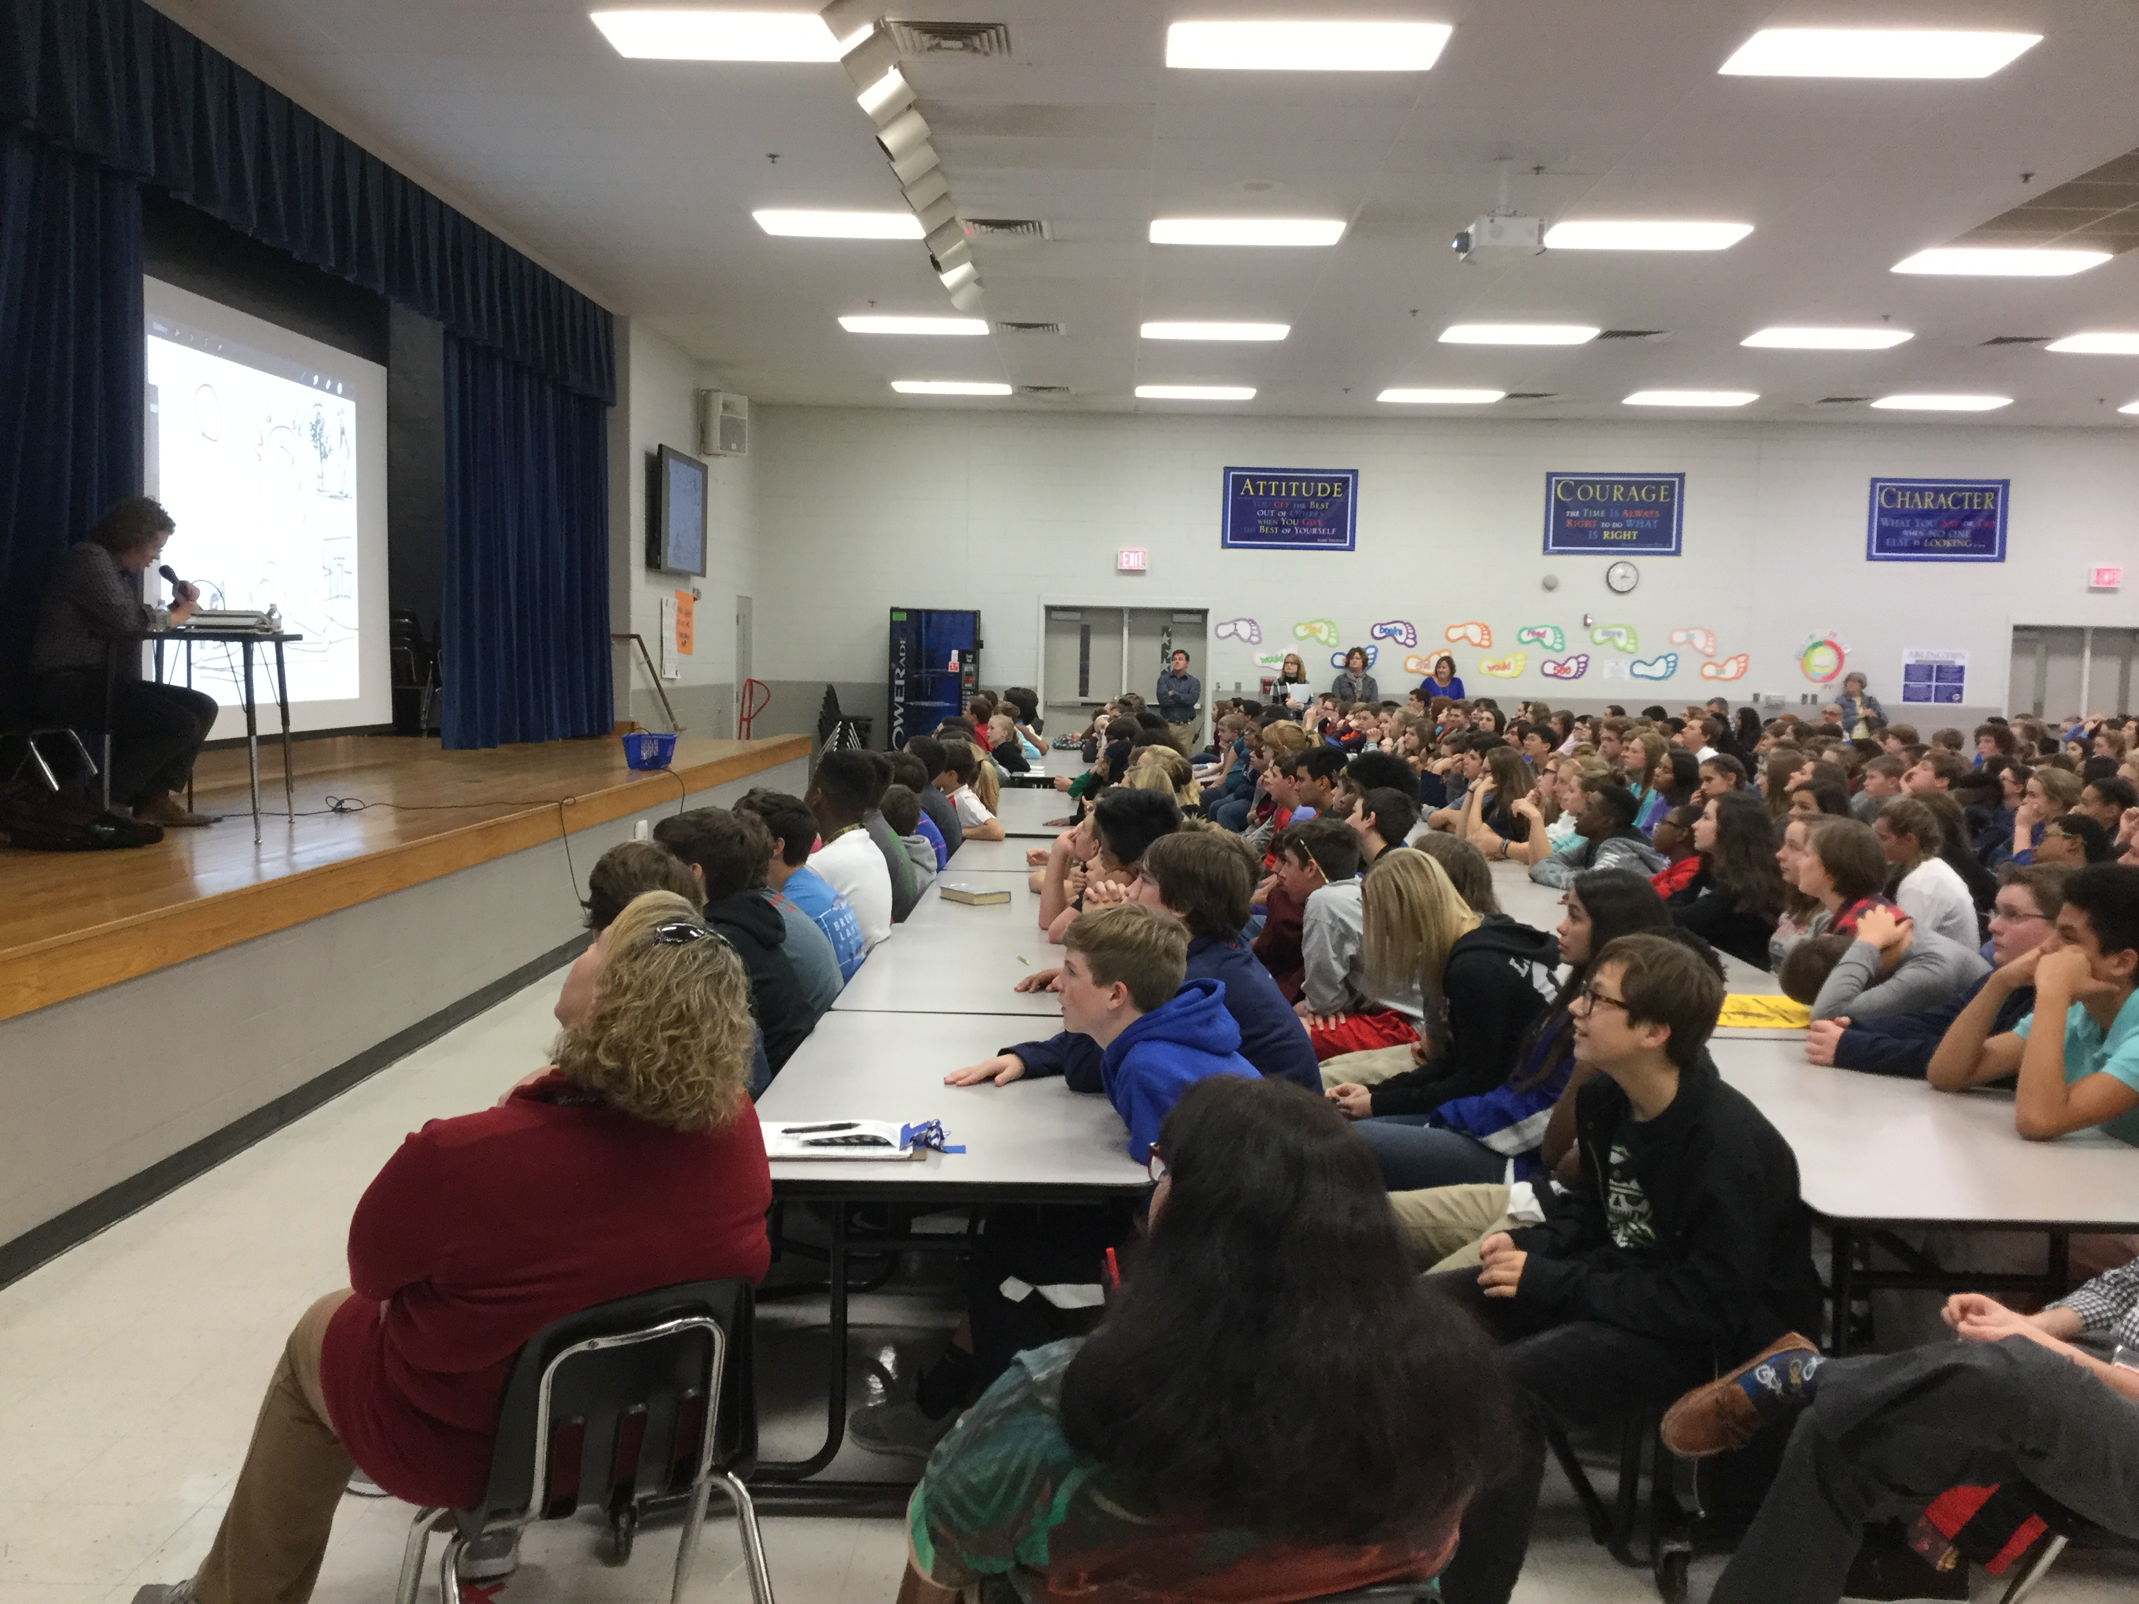

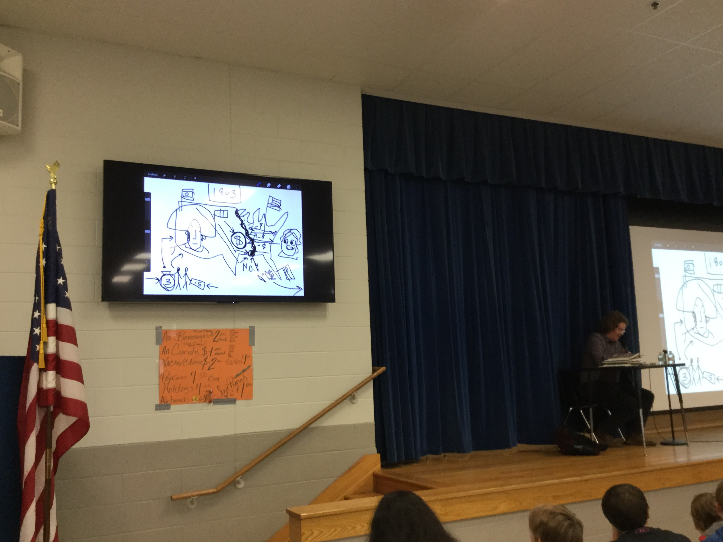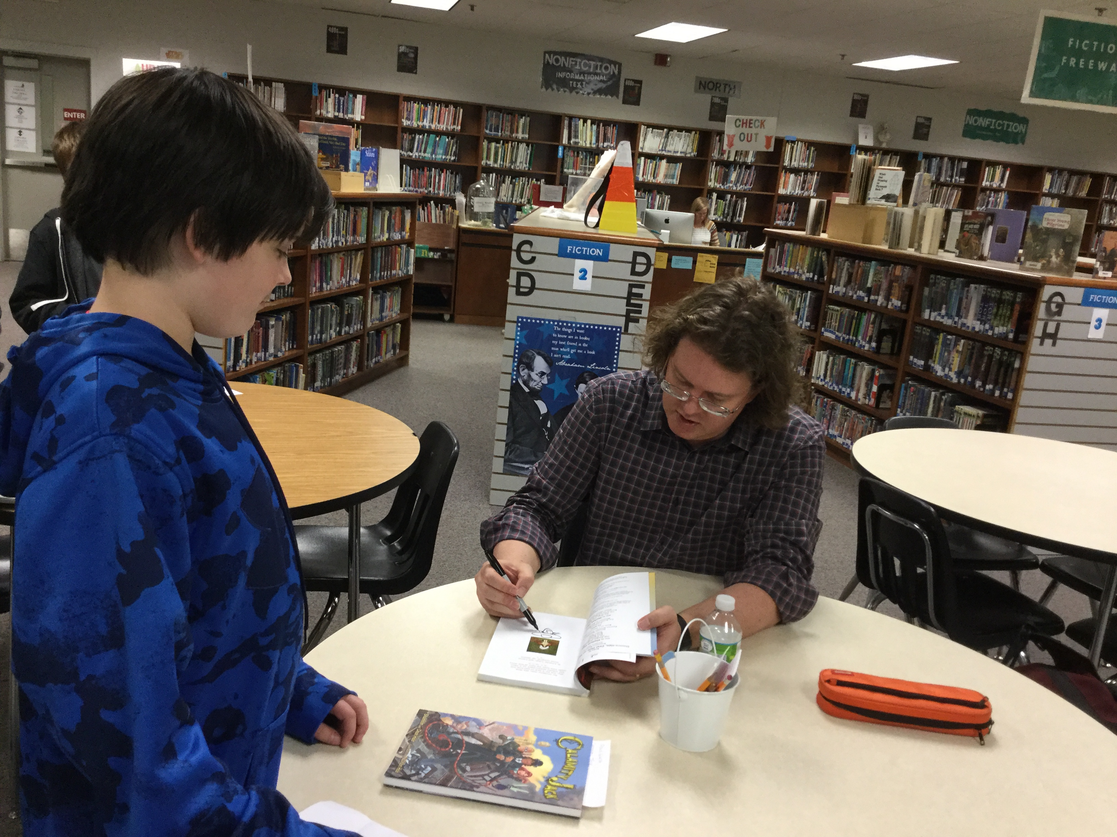

Mrs. Haggard received word this month that our library was chosen to receive an $8500 grant from author James Patterson, who since 2015 has given $3.5 million of his own money to support school libraries. Mrs. Haggard plans to buy ebooks, new and replacement print copies, and shelving for our library. In addition, Scholastic matched the grant amount in Scholastic dollars, which Ms. Alisa Jackson has received for her classroom library. (Picture on the reverse side.)
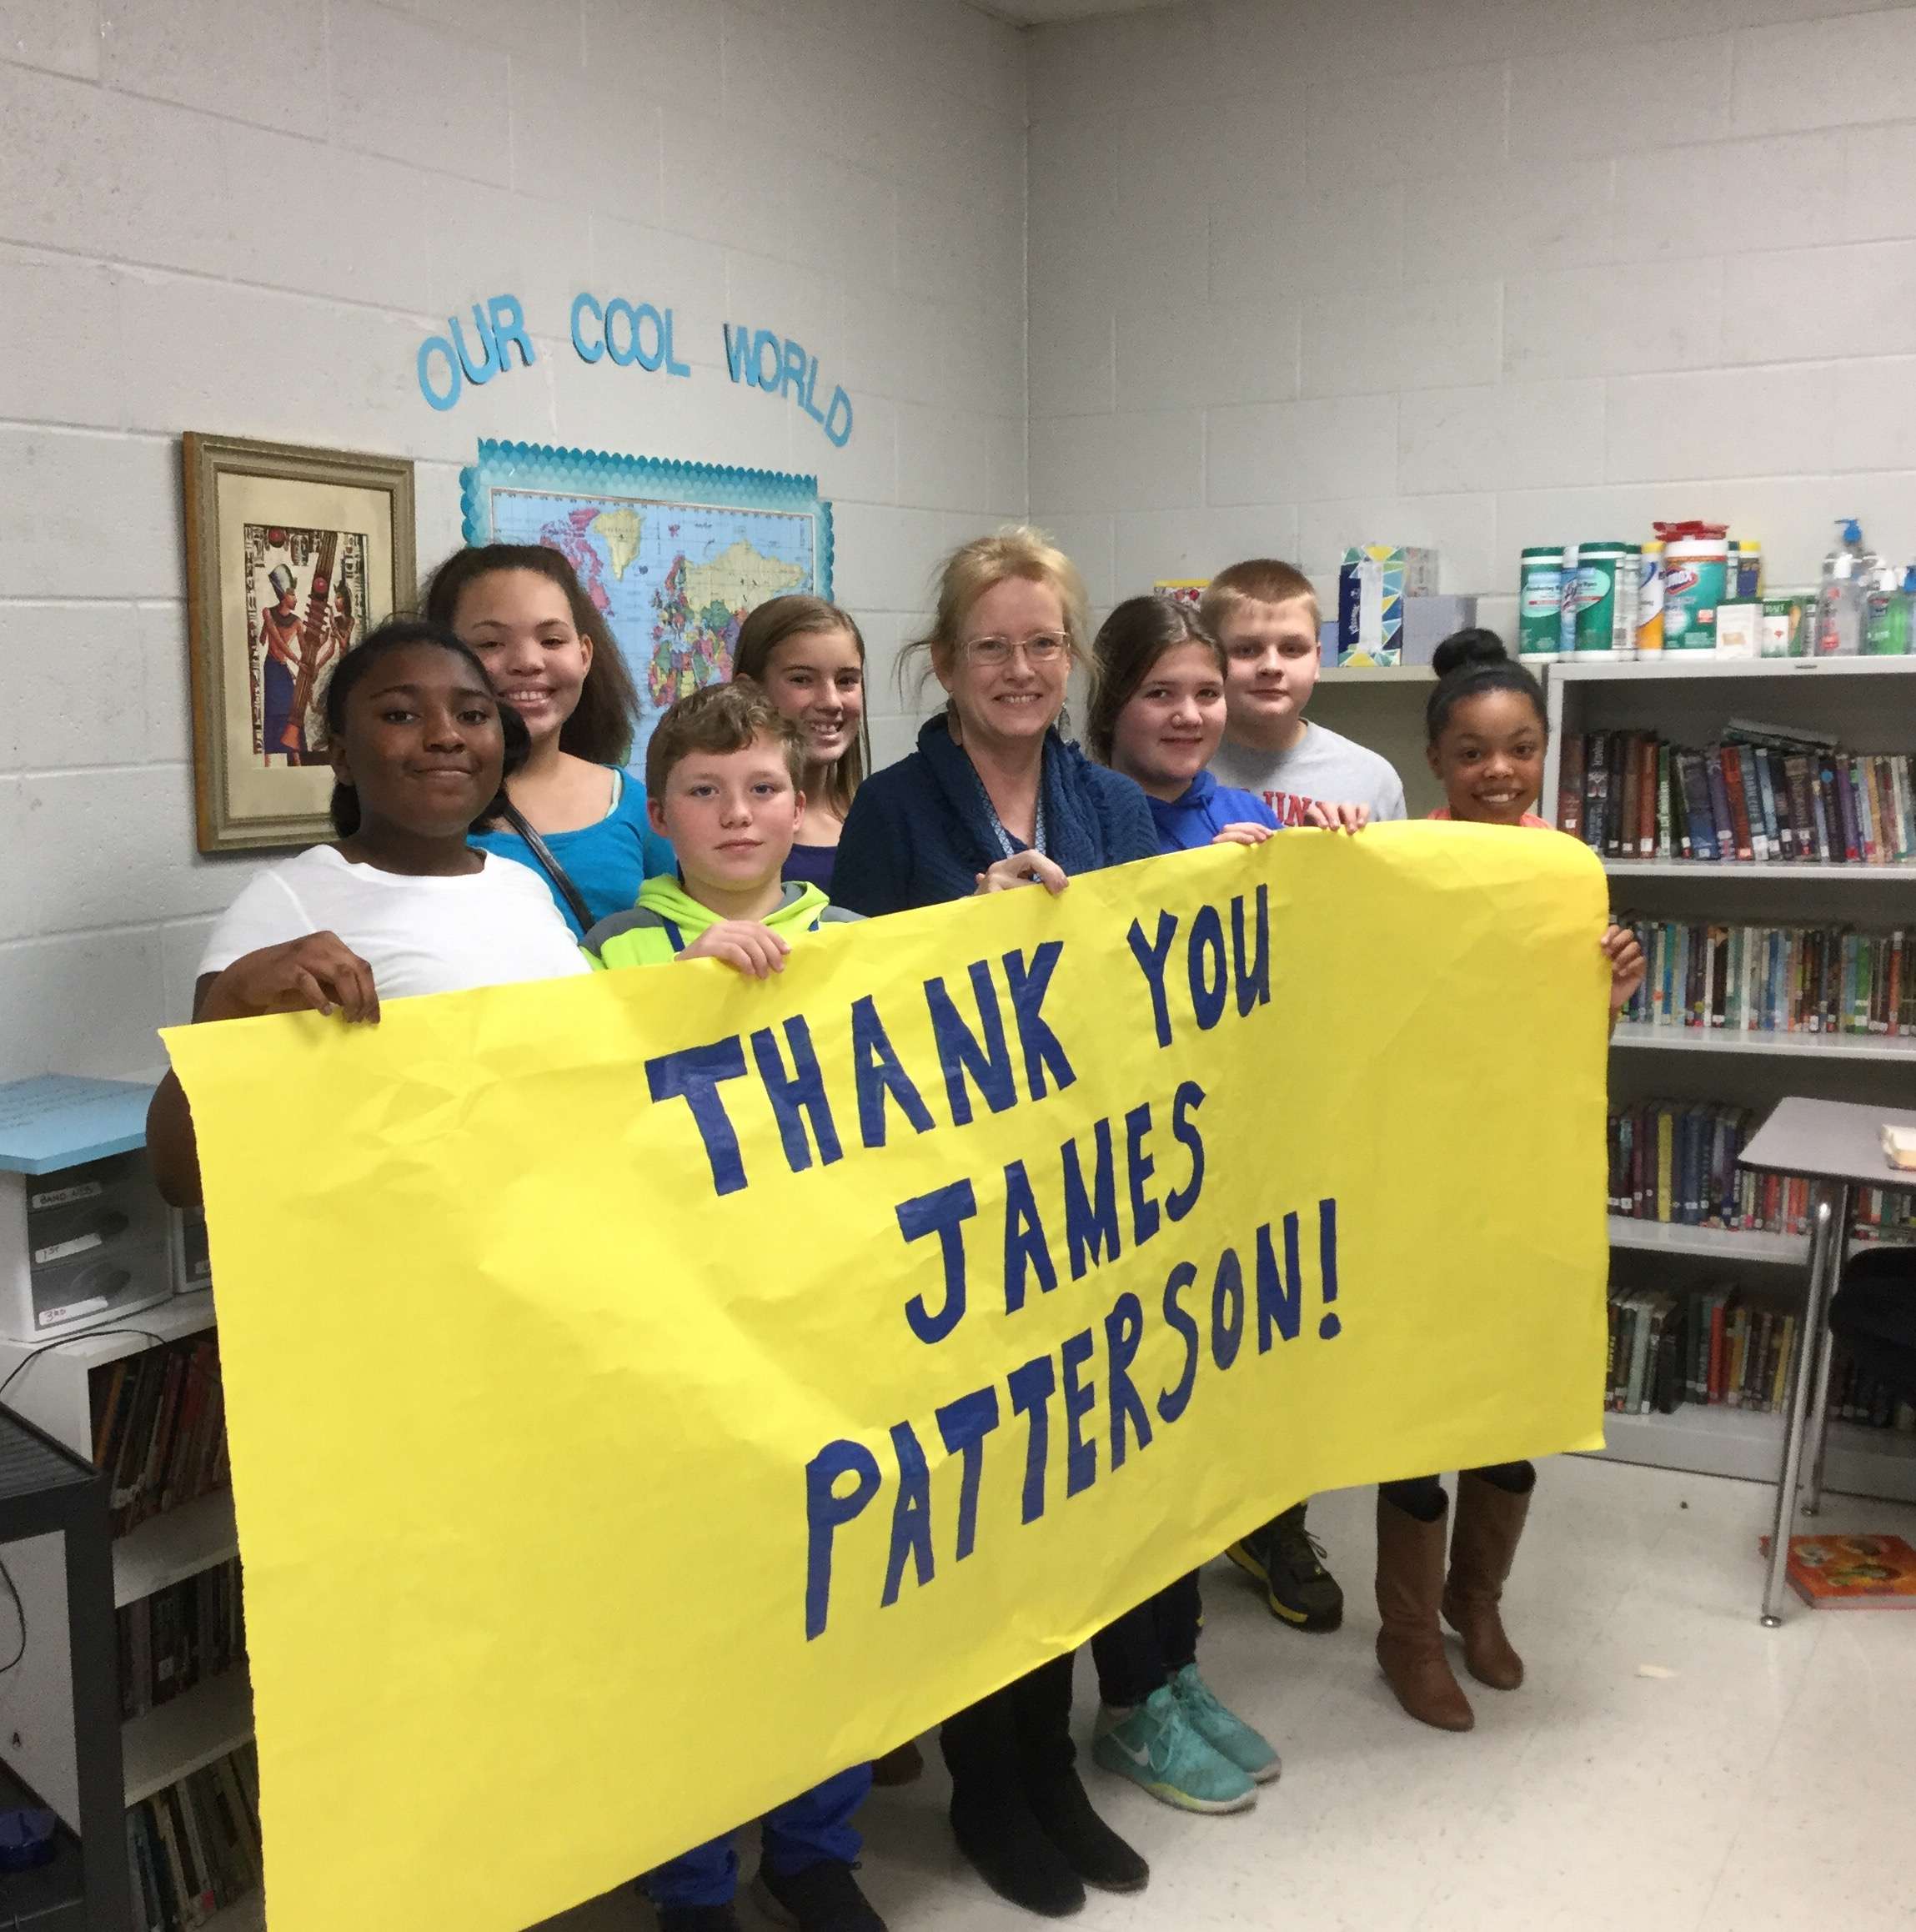

Stats Snapshot for the month:
- 1881 items print items checked out
- 1173 ebooks & audiobooks checked out or read online
- 178 holds placed
- 57 new print and 7 new digital titles added
- 3022 searches using databases supplied by Follett
- Britannica searches: 5930
- Computer carts booked 69 times
- Librarian taught 10 8th grade RICA classes to talk about different ways, especially visual, to present information and to recommend books; 12 8th grade science classes to assist them with their science literacy project; 2 7th grade STEM classes to point them to good sources for a research project
- Librarian attended TASL conference (TN Association of School Librarians) and shared info from the conference with ACS librarians
- Library used for 2 RTI meetings, health screenings, 2 Dance Parent meetings, 2 baby showers
- Adult volunteers: 86 hours
- Student Crew: 139 times

Arlington Middle School Library
Karen Haggard, Librarian
November 2016

