September Stats in the AMS library
Books checked out: 3,212

Computer carts: 75 times

New items added: 104 with 85 more on order

Volunteer hours: 106.5

Student Crew worked 151 times

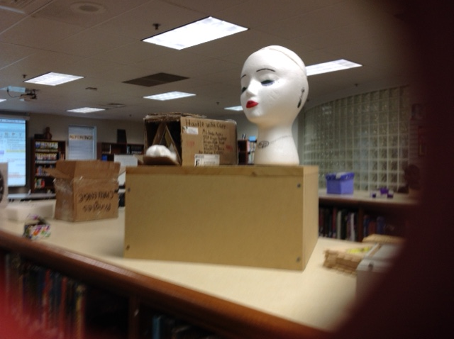
6th Grade Stem projects on display

Holds placed by AMS users: 268 (19 last month)

Digital usage: 553 eBooks checked out; 1,279 read online

Survey on eBooks got 583 responses

Teaching this month focused on using recently issued iPads to access library resources and included all 6th Grade RICA and STEM classes and all 7th Grade Language Arts classes. Students were taught to make a Destiny account to put books on hold and to access eBooks. In addition students were given information about getting a public library card and using it to access eBooks and audio books through TN R.E.A.D.S. Note the Holds Placed & Digital Book Usage stats above.

Librarian made presentations to parents on Conference Night and to Science teachers on District Learning Day.

Dance and Cheer boosters, ACS Librarians, National Junior Honor Society, and Parents of 6th graders getting iPads used the library for meetings. The library was also used for some of the iPad distribution.

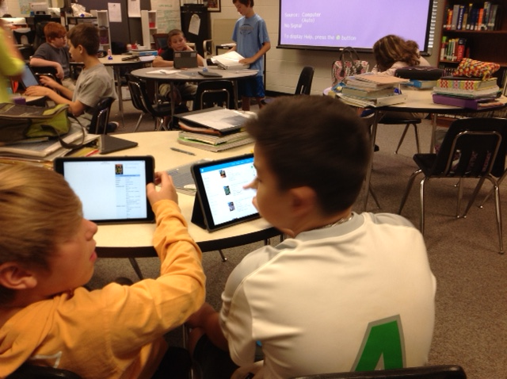
7th graders access library resources on iPads

