Log on to this address: www.arlington.follettdestiny.com
Choose Arlington Middle School. (Choose TN first if prompted.)
At the top right part of the page, choose Create Account.

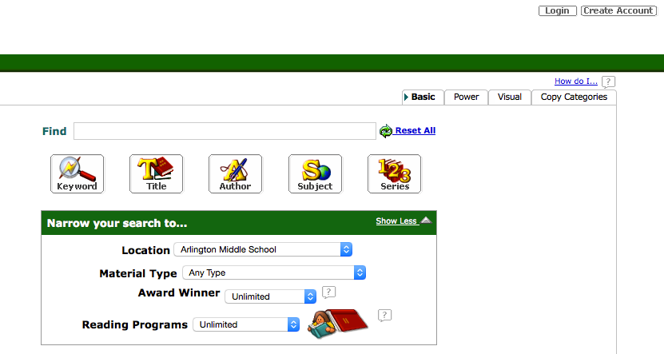

At the next screen, type in your last name and the number on your library barcode. You don’t have to type the P. Click Next.

The next screen will ask for your birthday. Use the pulldowns to choose yours.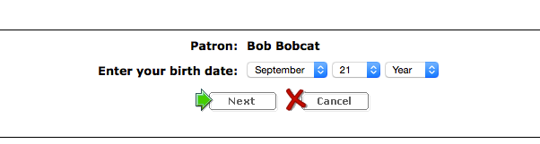 Click Next.
On the next screen, you will be prompted to choose a user name and password. Each user name has to be unique. I recommend that you use your library barcode number for this. You can also use it for your password if you choose. You do not have to add an email.
Click on Save.
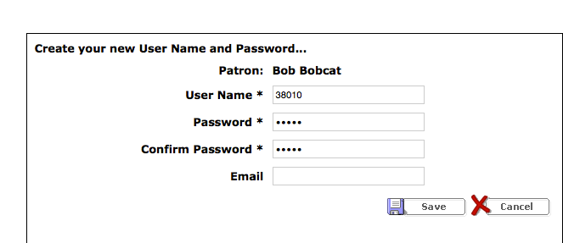

A new search screen will open. It looks like this:
Type your search in the Find box.

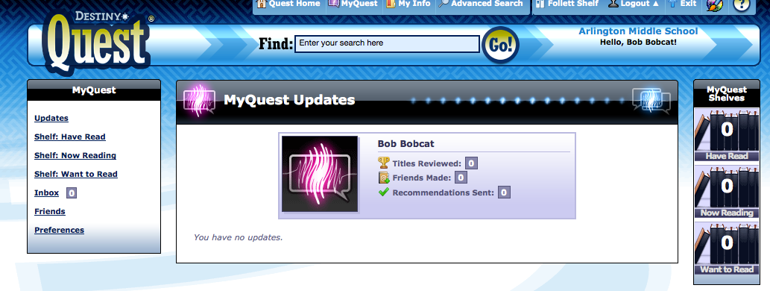
Your results should look like this:
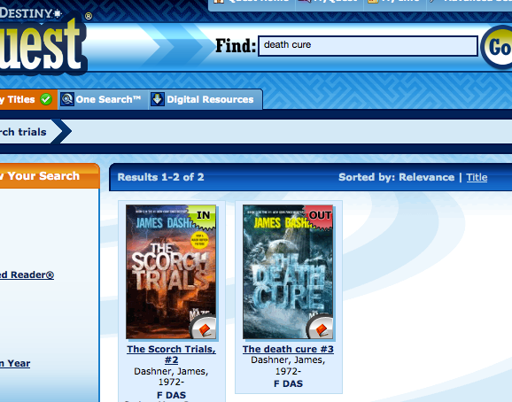

Click on the title of the book you want. You will get a new screen that looks like this:
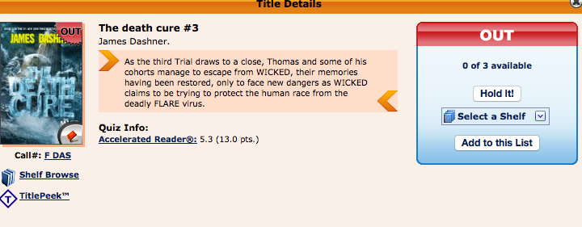

Click on the “Hold It!” button.

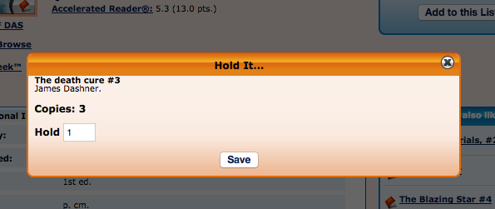

Read the message and then close the screen.

If you go back to the My Quest screen, using the button at the top, you can click on My Info to see your checkouts and your holds.
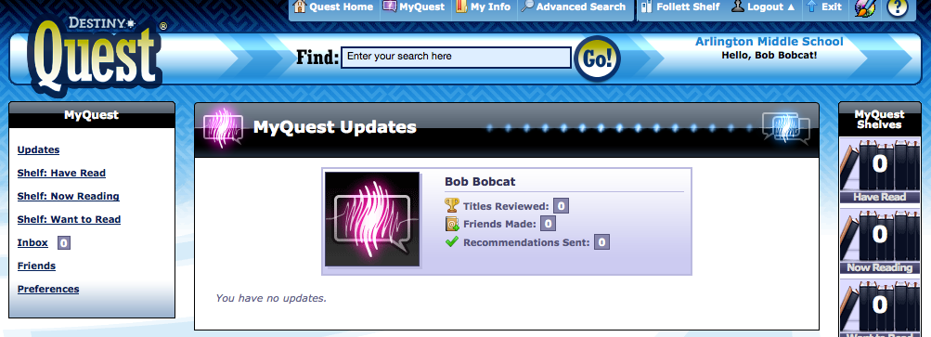 You can also make lists for yourself here of future books you want to read.

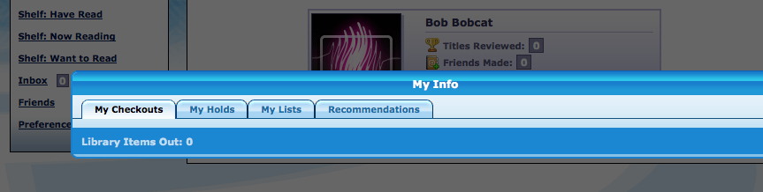

Play with the other features and use them at any time from any computer—even your phone.

Don’t forget to Log Out when you finish.

